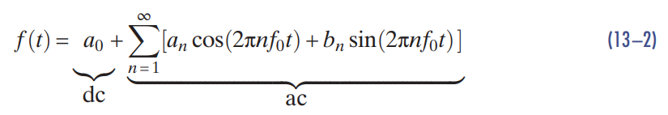

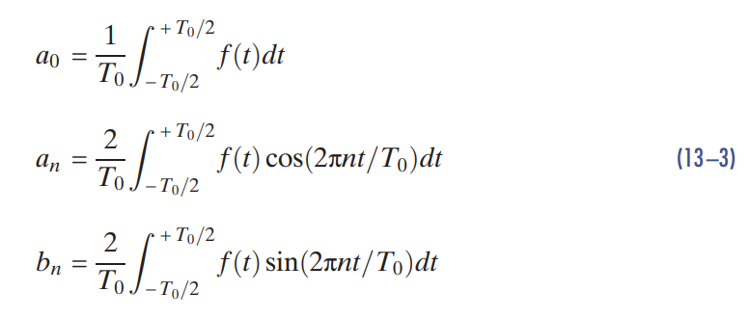

Impedance:

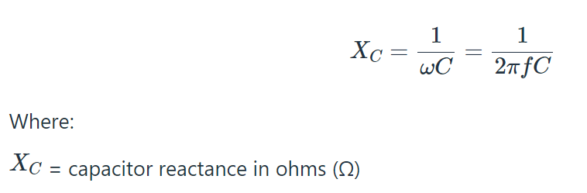

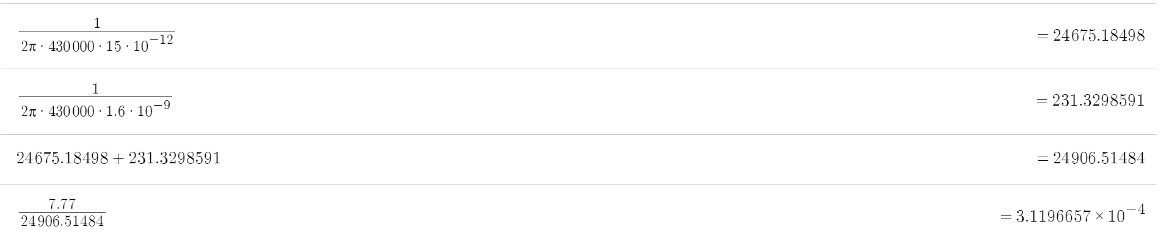

We are only going to get 0.311mA to go through the Voltage sensor branch, hence, we don’t consider it.

Therefore,



(5 Amps RMS through the secondary with 10% attenuation is 5.5)

Therefore we have 7.778 Amps

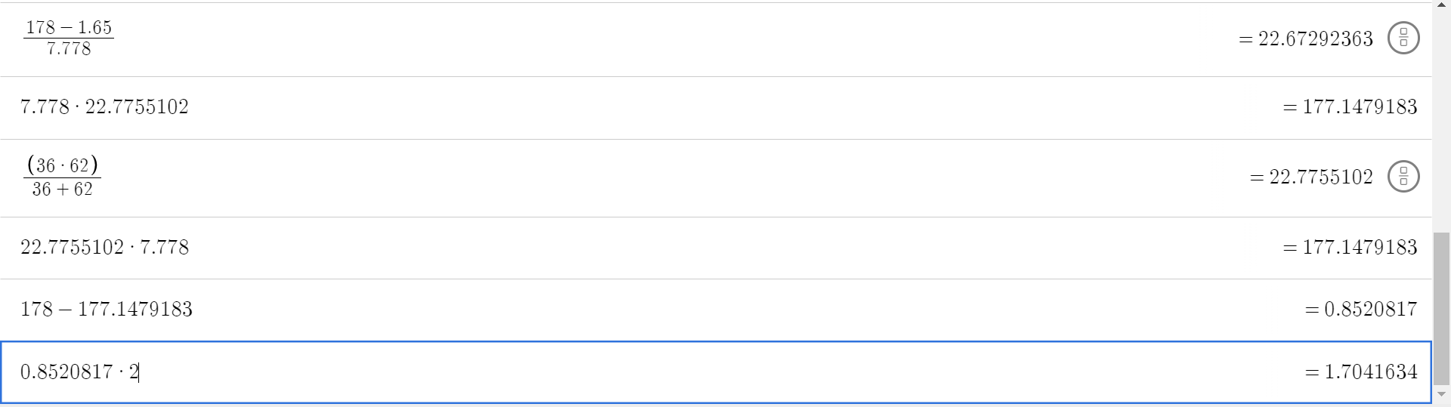

Therefore we must have a 22.67 Ohm resistor (can be approximately achieved with 36 and 62 Ohm resistor in parallel

Current Division:



2.86A through the 62Ohm resistor



4.92A through the 36Ohm resistor

2.7:

The reason why we are using the Isc and Voc values is to ensure we are setting the impedance to match what we desire on the output

1. Provide the correct output impedance and thevenin equivalent voltage to meet the output requirements
2. Acting as a filter than filtering out the non-fundamental harmonics

Transformer

$\int_{0}^{T/2}{}V_{pk}sin(2πft)dt=\frac{V_{pk}}{πf}$

$\frac{V_{pk}}{πf}=λ_{1} (Volt-seconds)$

$\frac{V_{pk}}{πf}<n*2ΔB*A_{c}$